Weekly Report(Up until 18th January, 2016)
Anirudh Tiwari

Work Done
Following are the plots of running my scripts on the data set I created.

Results
Single Domain vs Two Domain Proteins

Length vs Interaction Energy
(red dots→ single domain, blue dots→two domain contiguous, green dots→ two domain non-contiguous)

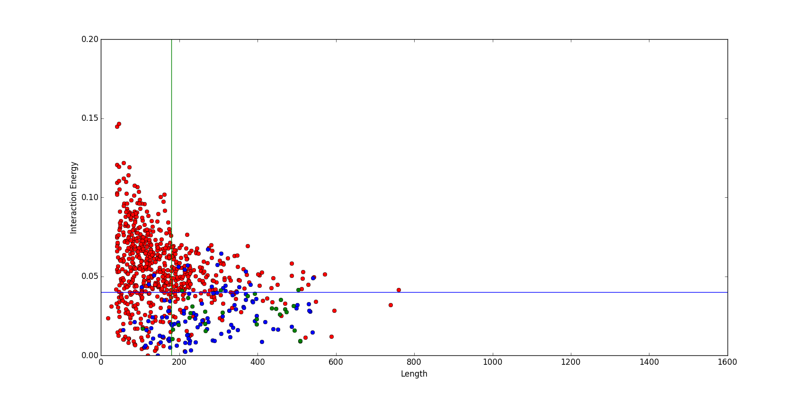

 | Length | Interaction Energy | Single Domains correctly Identified
Single vs Two | >=150 | <=0.04 | 575/647(88%)

Two Domain vs Three Domain Proteins

Length vs Interaction Energy
(red dots→ two domain, blue dots→three domain contiguous, green dots→ three domain non-contiguous)
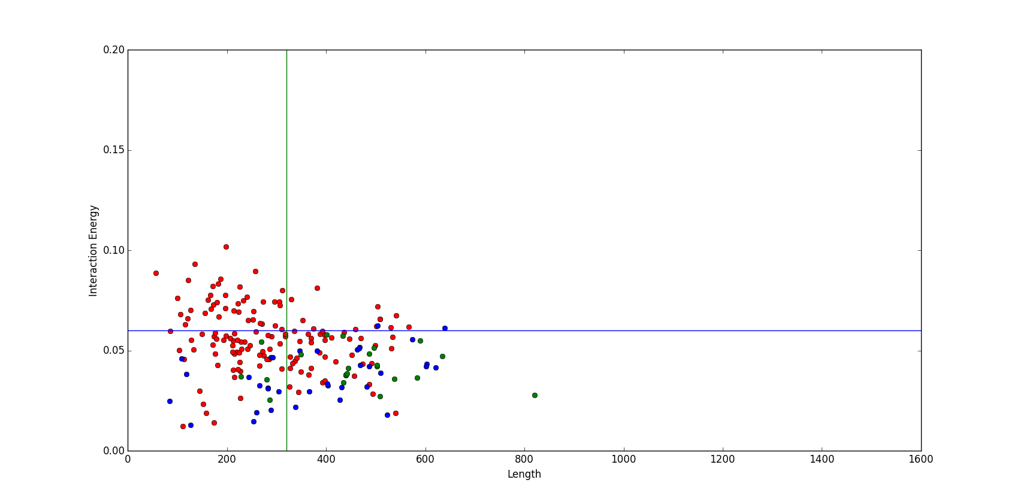

 | Length | Interaction Energy | Two Domains Correctly Identified
Two vs Three | >=320 | <=0.06 | 105/144(73%)

Three Domain vs Four Domain Proteins

Length vs Interaction Energy
(red dots→ three domain, blue dots→four domain contiguous, green dots→ four domain non-contiguous)

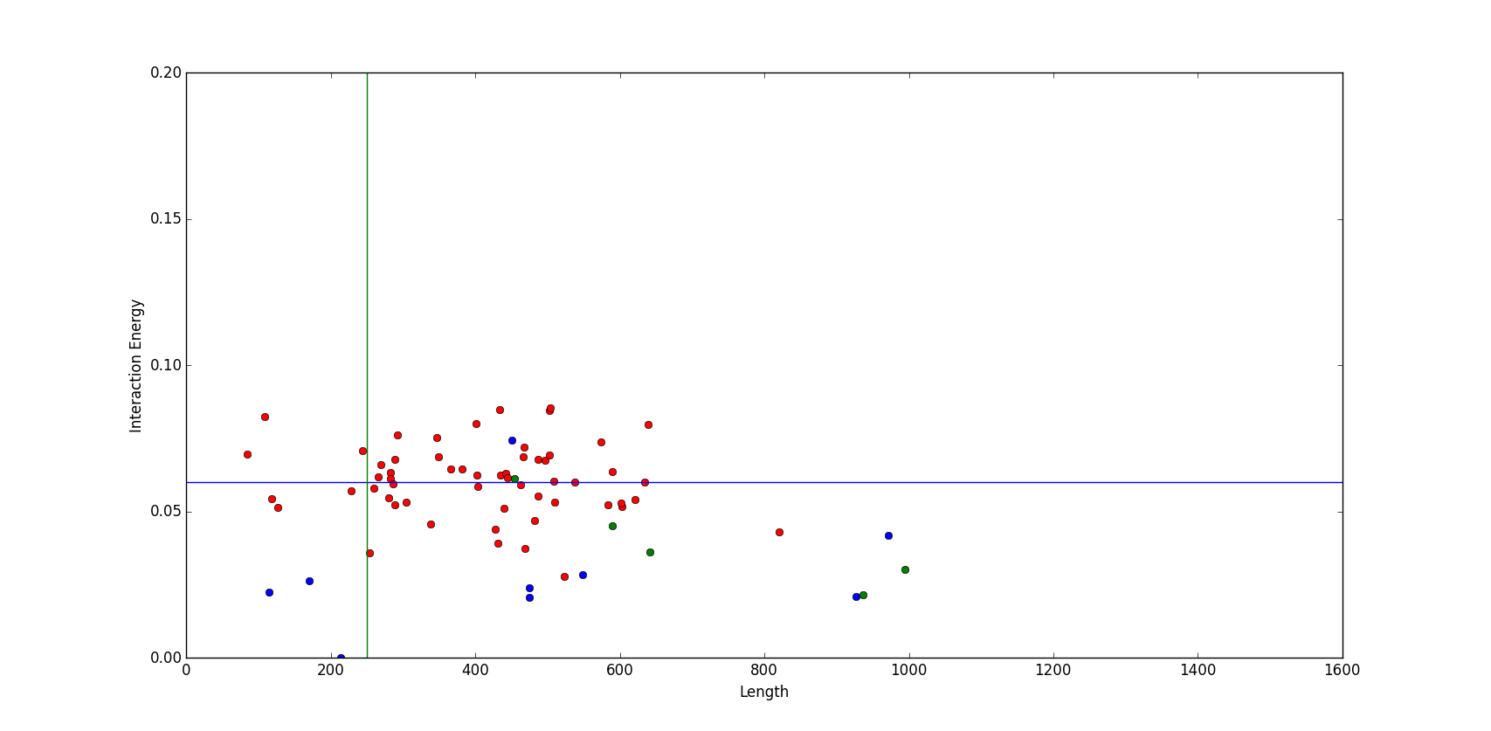

 | Length | Interaction Energy | Three Domain Proteins Correctly Identified
Three vs Four | >=250 | <=0.06 | 34/57(59.6%)
Four Domain vs Five Domain Proteins

Length vs Interaction Energy
(red dots→ four domain, blue dots→five domain contiguous, green dots→ five domain non-contiguous)

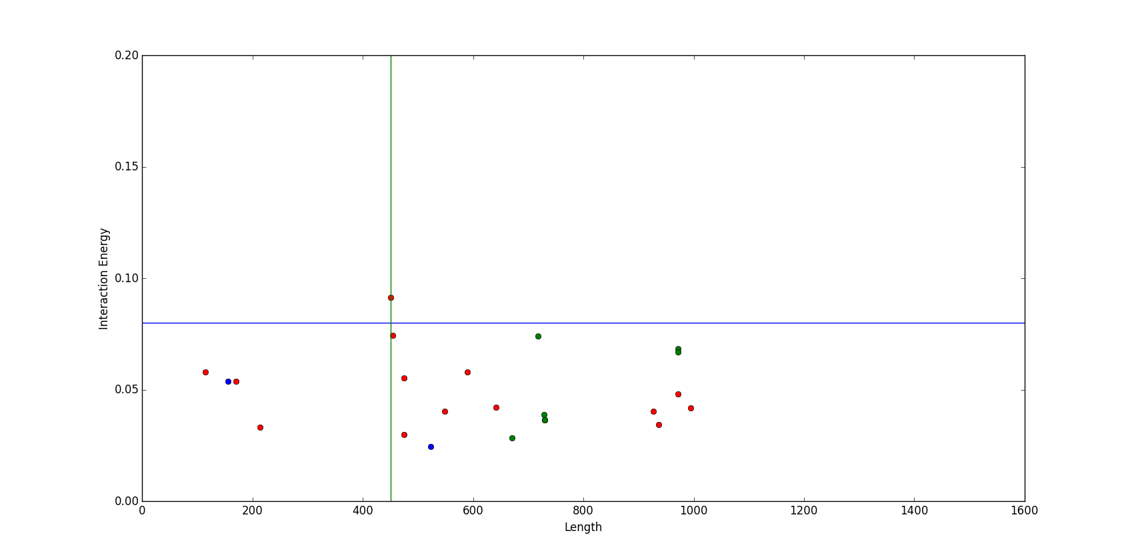

 | Length | Interaction Energy | Four Domain Proteins Correctly Identified
Four vs Five | >=450 | <=0.08 | 4/14(28.5%)

